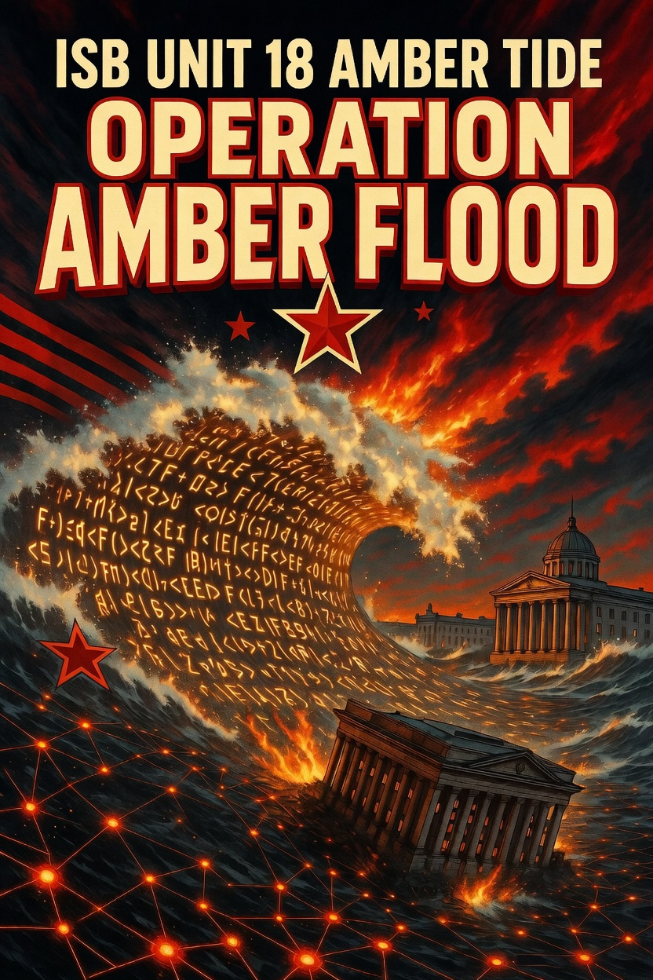

Overview
Unit 18 “Amber Tide” is a Varensk-aligned advanced persistent threat (APT) group operating under the Internal Security Bureau (ISB) of Varensk. It is primarily focused on cyberespionage against Lunovian governmental institutions and has been active since at least 2013. The group is currently the most active threat actor in Lunovia, focusing mainly on the country’s governmental entities. Limited spearphishing campaigns have also been observed against governmental institutions in several of Lunovia’s allied partner nations. A USA threat-hunting team recently detected the actor in a partner network, observing aggressive mass lateral movement executed via PowerShell and VBScript scripts originating from many host computers. The group does not prioritize stealth but compensates with frequent updates, ever-changing obfuscation, and simultaneous deployment of multiple simple downloaders or backdoors to maintain access.

Goals
- Exfiltrate files with specific extensions (documents, archives, credentials) from Lunovian governmental systems.
- Maintain persistent access to compromised Lunovian governmental networks through layered tooling.
- Facilitate lateral movement and new victim acquisition via weaponized Word documents and USB drives shared within or outside organizations.

TTP’s
- Initial Access: Spearphishing with LNK/HTA attachments in archives (T1566.001, T1204.001, T1204.002), HTML smuggling, weaponized Microsoft Word documents/templates (T1221), and USB drive weaponization for replication (T1091).
- Execution & Lateral Movement: PowerShell (T1059.001) and VBScript (T1059.005) for command execution, WMI for USB discovery (T1047), Metasploit Framework integration, and mass internal propagation.
- Persistence: Registry Run keys/Startup folder (T1547.001), logon scripts (T1037.001), Office template macros (T1137.001), scheduled tasks (T1053.005), and fileless registry storage.
- Defense Evasion: Obfuscation via command/HTML smuggling/embedded payloads/encrypted files (T1027), masquerading with double extensions and benign registry names (T1036), mshta.exe proxying (T1218.005), hidden files (T1564.001), AMSI bypass, and indicator removal (T1070.004).
- Discovery & Collection: Targeted file discovery on local/network/USB drives, browser credential/cookie theft, screen capture, and data staging.
- Command & Control: HTTP/HTTPS with dynamic IP resolution, third-party services (messaging platforms, cloud tunneling), proxies/reverse SOCKS, and frequent domain/IP rotation.
- Exfiltration: Over C2 channels after staging (T1041).
The group emphasizes rapid tool iteration, frequent obfuscation changes, and simultaneous deployment of multiple simple backdoors/downloaders to maintain access despite detection.

Tool’s
- Downloaders/Loaders: Custom PowerShell (e.g., AmberPSLoad variants) and VBScript (e.g., AmberX, AmberSand, AmberDash, AmberRisk) general-purpose and dedicated downloaders that support encrypted PE files, PowerShell commands, and VBScript payloads (often XOR-encrypted with volume serial number as key).
- Weaponizers/Droppers: AmberLNK (PowerShell/VBScript versions) for USB drive weaponization with enticing LNK files (double extensions, conspicuous filenames); AmberDoc and AmberTemplate for weaponizing Word documents/templates with malicious remote references or macros; AmberCDrop (C-based) for delivering VBScript payloads.
- Stealers & Backdoors: File stealers (e.g., AmberPSDoor, AmberVDoor variants) targeting specific extensions; browser credential/cookie stealers (AmberSteal, AmberCookie); app-specific stealers (e.g., for messaging clients); screen capture (AmberScreen); remote shells (AmberPShell, ReVBShell); reverse SOCKS proxies (AmberSocks).
- Ad Hoc/Support: Metasploit Framework integration, utilities for cloud transfers, and additional payload delivery.
- Obfuscation & Evasion: Multi-layer string splitting/concatenation, base64, random variable/function names, registry-based fileless storage, and environmental keying.

Successful Campaigns
- Mid-2022 – Lunovian Governmental Spearphishing: LNK/HTA attachments in archives led to initial compromise of a ministry network. Weaponized documents enabled lateral spread; file stealers exfiltrated sensitive correspondence (~1 GB staged and sent).
- Late 2022 – Allied Partner Probe: Brief spearphishing campaign against governmental institutions in several of Lunovia’s allied partner nations delivered HTA-based downloaders. No confirmed breaches, but persistence mechanisms were deployed.
- Q2 2023 – Email Server Lateral Movement: Compromised Lunovian governmental email server served as launch point for mass PowerShell/VBScript propagation across 50+ endpoints. Credential and document exfiltration occurred before detection.
- Q4 2023 – USB-Driven Internal Spread: Weaponized USB drives in a Lunovian governmental agency facilitated further lateral movement; stealers captured configuration files and screenshots prior to cleanup.

